**C.V**

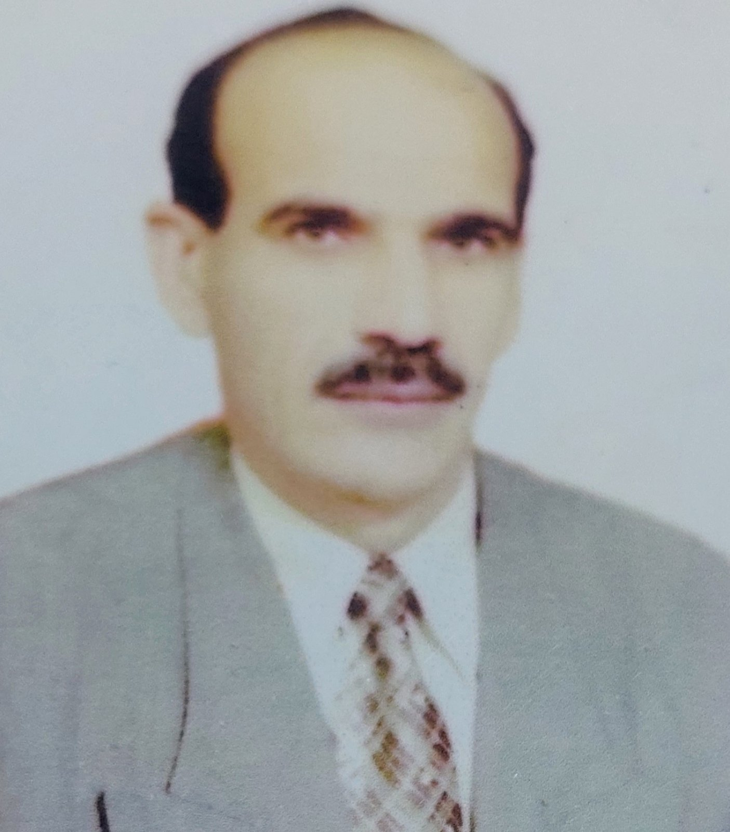

Photo

**Name: Hussein Kadhum Eulewi.**

**Date of Birth:1/ 7/ 1962**

**Martial statues: married.**

**No. of children: 2**

**Religion: Muslim.**

**Specialization:** remote sensing and geographic information systems

**Job: Teaching**

**Scientific Degree:** Assistant Professor.

**Work Address: Al-Qasim Green University / College of Environmental Sciences**.

**Work Phone:-----**

**Mobile: 07706035476**

**E-mail:** [**huskad.1962@environ.uoqasim.edu.iq**](mailto:huskad.1962@environ.uoqasim.edu.iq)

[**huskad.kad@gmail.com**](mailto:huskad.kad@gmail.com) **E-mail:**

* **First: Scientific certification.**

|  |  |  |  |
| --- | --- | --- | --- |
| **Date** | **College** | **University** | **Degree science** |
| 2005 | faculty of Agriculture | University of Babylon | assistant teacher |
| 2009 | faculty of Agriculture | University of Babylon | Teacher |
| 2020 | **College of Environmental Sciences**. | Al-Qasim Green University | Assistant Professor |

* **Second: University Teaching.**

|  |  |  |  |
| --- | --- | --- | --- |
| **From -To** | **The (Institute / College)** | **University** | **No.** |
| 2005-2013 | faculty of Agriculture | University of Babylon | 1 |
| 2013-2021 | **College of Environmental Sciences**. | Al-Qasim Green University | 2 |

* **Third: Courses Which You Teach.**

|  |  |  |  |
| --- | --- | --- | --- |
| **Year** | **Subject** | **Department** | **No.** |
| **2006-2012** | Principles of plane | **Soil and Water Resources** | 1 |
| **2008- 2012** | Meteorology | Soil and Water Resources | 2 |
| **2007- 2009** | air conditions | Soil and Water Resources | 3 |
| **2008-2010** | morphology | Soil and Water Resources | 4 |
| **2009-2010** | Soil survey and classification | Soil and Water Resources | 5 |
| **2009- 2012** | remote sensing | Soil and Water Resources | 6 |
| **2013- 2020** | Geology | environment/environmental pollution | 7 |
| **2014-2020** | desertification | Environmental pollution | 8 |
| **2015- 2021** | Environmental systems conservation | Environmental pollution | 9 |
| **2013-2016** | climatic changes | Environmental pollution | 10 |
| **2016-2021** | remote sensing | Environmental pollution | 11 |
| **2019-2021** | Sustainable development | Environmental pollution | 12 |

* **Fourth: Research Projects in The Felid of Specialization.**

|  |  |  |  |
| --- | --- | --- | --- |
| **No.** | **Research Title** | **Place of Publication** | **Year** |
| 1 | **Desertification in the Bahr al-Najaf region and its impact on the environment.** | **research project** | **2021** |
| 2 |  |  |  |
| 3 |  |  |  |

* **Fifth: Awards and Certificates of Appreciation.**

|  |  |  |  |
| --- | --- | --- | --- |
| **Year** | **Donor** | **Name of Awards and Certificates** | **No.** |
| **2020-2021** | **Evaluation of doctoral theses and dissertations for the College of Agriculture and Forestry / University of Mosul** | **Letter of thanks** | **1** |
| **2020-2021** | **Research evaluation of the Journal of Rafidain Agriculture / University of Mosul** | **Letter of thanks** | 2 |
| **2019** | **President of Al-Qasim Green University** | **Letter of thanks** | 3 |
| **5 /9/ 2019** | **Mr. Dean of the Faculty of Environmental Sciences** | **Letter of thanks** | 4 |
| **11/2/2019** | **Mr. Dean of the Faculty of Environmental Sciences** | **Letter of thanks** | 5 |
| **2016** | **President of Al-Qasim Green University** | **Letter of thanks** | 6 |
| **2020** | **Mr. Minister A. Dr.. Qusai Abdul-Wahab Al-Suhail** | **Letter of thanks** | 7 |
| **2019** | **President of Al-Qasim Green University** | **Letter of thanks** | 8 |
| **2020** | **Continuing Education Center** | **certificate** | 9 |
| **2020** | **Continuing Education Center** | **certificate** | 10 |
| **2020** | **College of Environmental Sciences** | **certificate** | 11 |
| **2019** | **Karbala University** | **certificate** | 12 |